[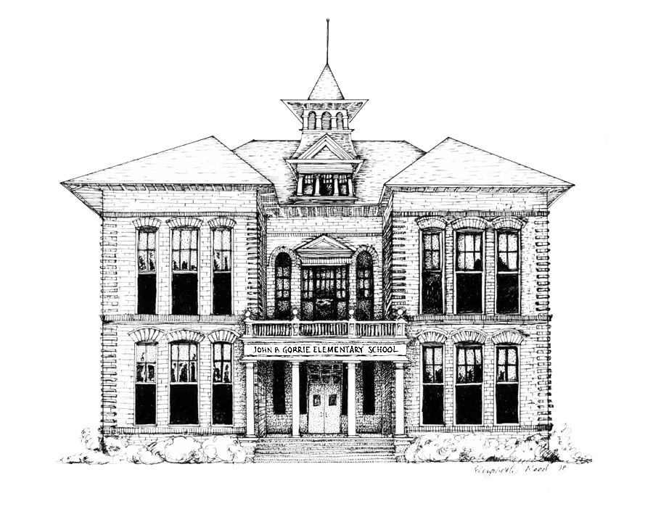](http://www.sdhc.k12.fl.us/~gorrie.elementary/)

# Principal

Marjorie Sandler

**Assistant Principal for Elementary Instruction**

Alesha Looper

**Hillsborough County Public Schools**

**John B. Gorrie Elementary School**

Welcome Gorrie Jaguars,

**Welcome back to the 22-23 school year!!** We are so excited to have students back at school! Please be sure to read the first day packet information carefully which is located on the Gorrie Elementary website. Our web address is www.hillsboroughschools.org/gorrie Scroll down the page until you see Announcements and Click on the First Day Packet. The updated packet will be located there. Please read the dismissal information and be prepared to tell your homeroom teacher how your child will be dismissed each day. **The first day of school is Wednesday, August 10th.**

Here are some quick details for arrival and dismissal for this year:

**Arrival: (Parents will be allowed to walk students to class the first day of school only.)**

Parents may walk students to the entrance of our Gorrie Patio which is located on DeLeon. We must all say our goodbyes at the entrance of the courtyard (and quick goodbyes in the car line, please). We will have ample staff available to walk students to class. Students may arrive as early as 7:10 (not before). School starts promptly at 7:40, and students are expected to be in their classrooms at that time. The car line is busiest between 7:20-7:35, so please be patient. Please remember that our car line is a **NO CELL PHONE ZONE.**

**Staff will greet the buses on Horatio Street and guide students to their classrooms.**

**Dismissal Times: We use a program called Curb Smart to help make dismissal safe and efficient. We encourage parents to utilize our Pick-up Line. Your child(ren) will be given a number. You will receive 2 hang tags with that specific number. We ask that the number be posted in your windshield each day at dismissal. When you arrive, your student(s) will be called from their classroom to the front of the school. We will have teachers located along the line who will assist students to their cars.**

**Student Pick up – Parents will need to wait on the opposite side of the street from the school on DeLeon. The students will be dismissed in waves to a parent or guardian. Please do not walk up to the courtyard as this will interrupt the flow of dismissal. It is our number one goal to keep our students safe!**

**Dismissal Times are as follows:**

**1:45 Kindergarten**

**1:50 Grades 1 and 2**

**2:00 Grades 3, 4 and 5**

**Water bottles:**

The drinking fountains have been turned off, but our water bottle fillers are in full operation. We are encouraging all students to bring a reusable water bottle to fill up at our water bottle filling stations. Please make sure your **child’s name** is written on the water bottle. If your child forgets a water bottle, we will have cups on hand to provide water for the day.

**Class Placements:**

My staff and I have put many hours over the summer into placing students into classes. It is one of the most challenging puzzles we do each year. We are over class size in every grade level and cannot entertain any movement at this time.

**Volunteers:**

We are excited to have volunteers! Please make sure that you have completed the online Y.E.S. form on the district website. This form must be completed and approved each year before volunteers can be on campus.

We have been working extremely hard to make sure we provide your child with the best educational experience! We look forward to seeing you!

Thank you,

Marjorie Sandler, Principal